**Step1**: Goto manage plugins and download the slack notification plugin   
  
**Step2**: Create workspace for that login in slack portal page and login through gmail after that you can create workspace name.  
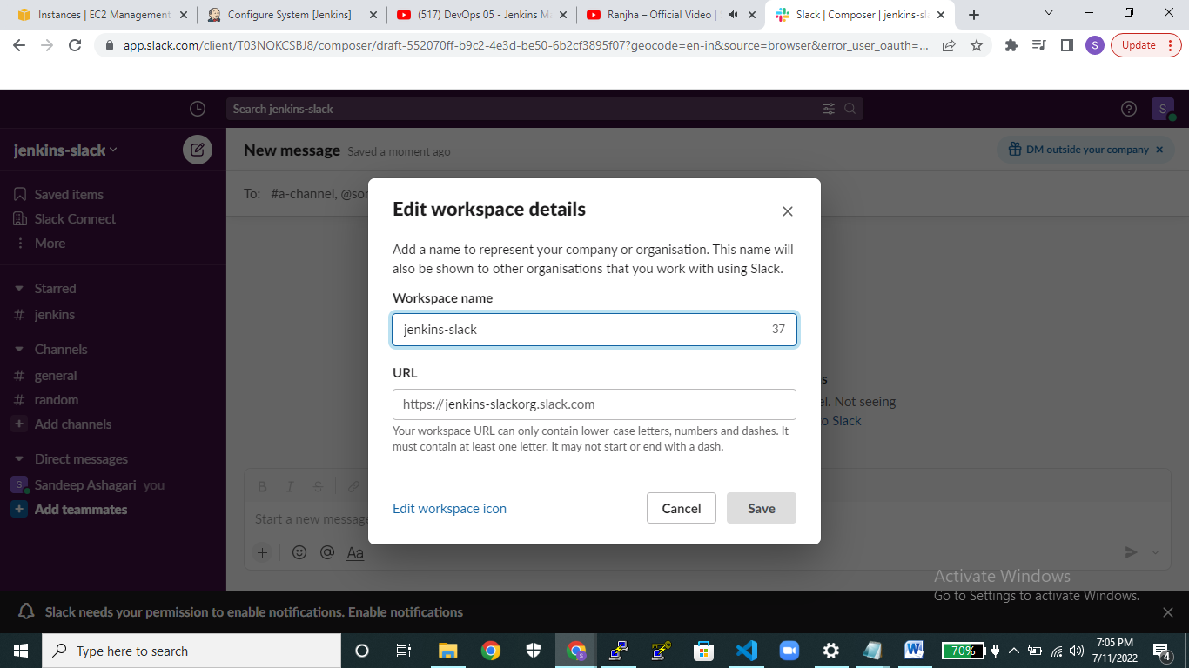  
  
  
**Step4**:create channel in slack for that click on add channels and create it.  
  
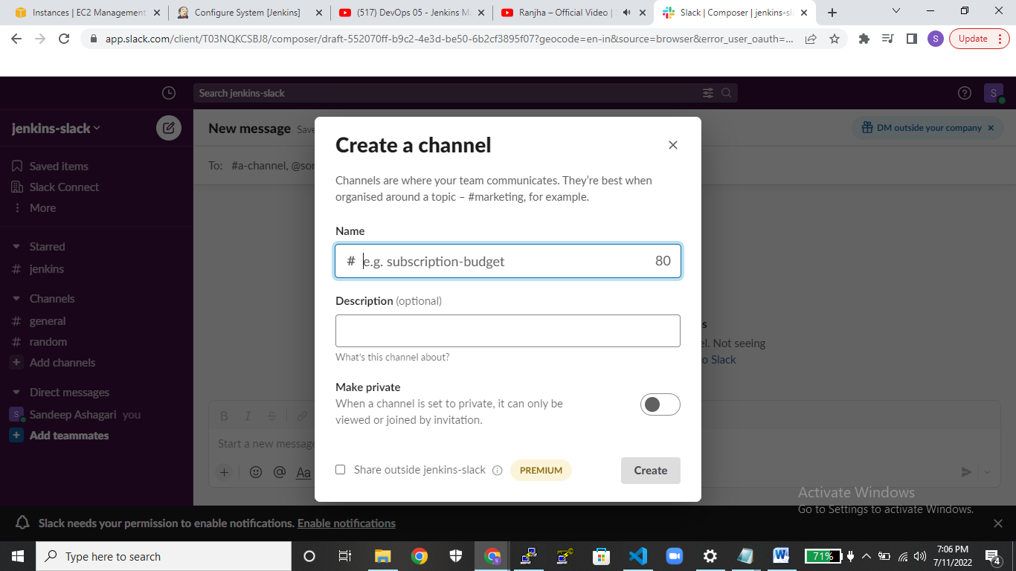  
  
 **Step5**: create the slack-token click on more and select the apps and search the name as **jenkinscI** and click on add to slack.  
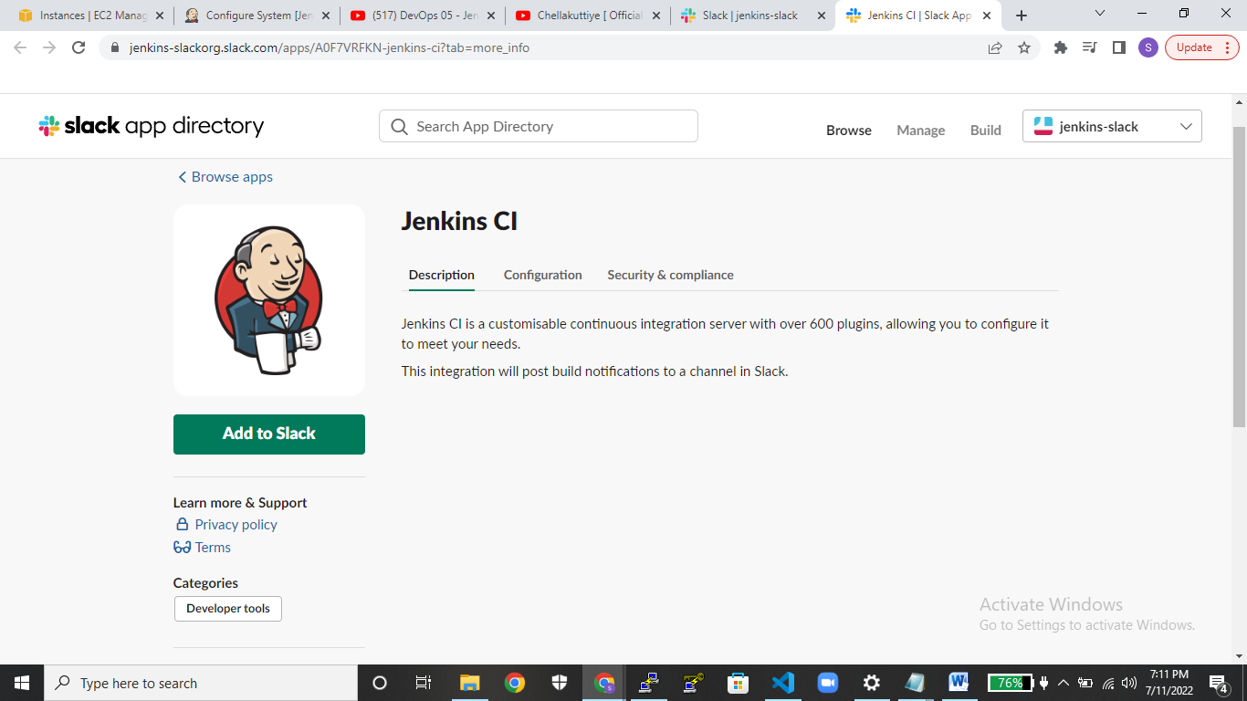  
 **Step6:**  After clicking add to slack button we need to select the post to channel as what ever channel you have created yet and then choose that channel & click on add Jenkins ci integration.  
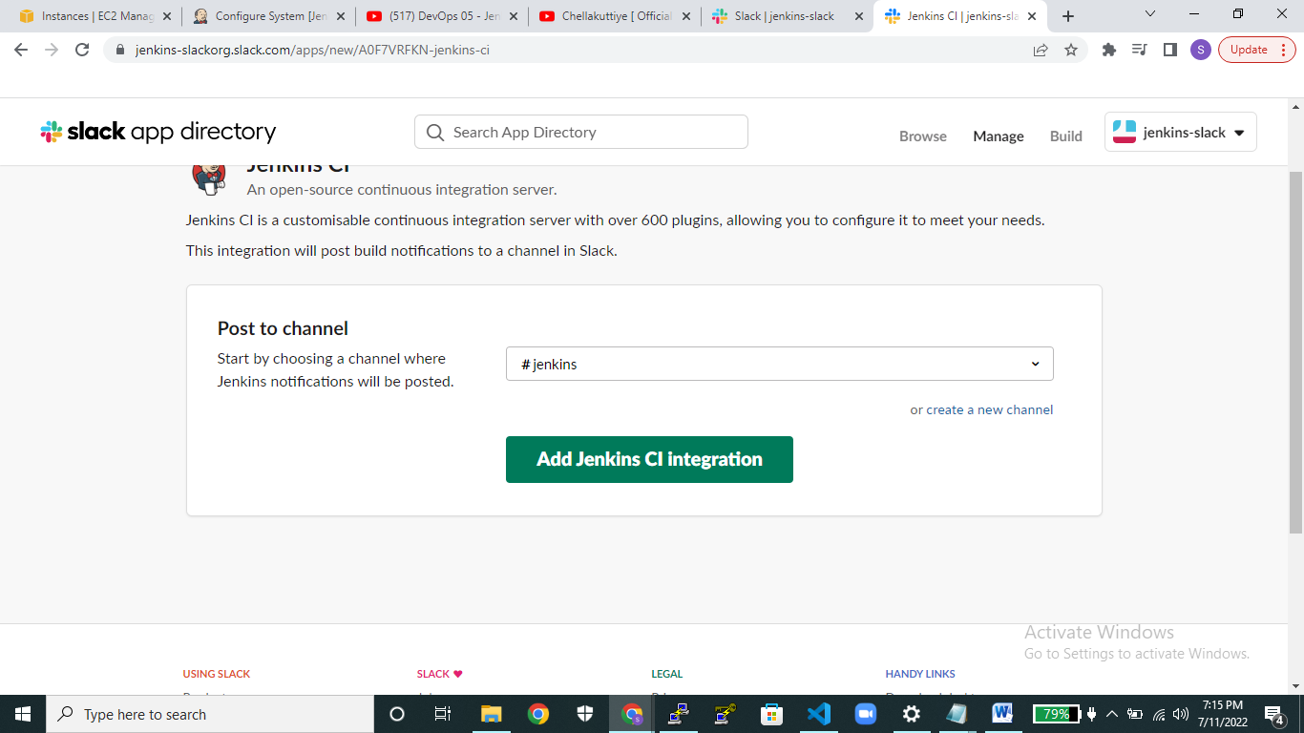  
 **Step7**:After clicking on **add** **Jenkins ci integration** scroll down the page integration settings select the token and copy it on your local desk and saveitsetting button.  
  
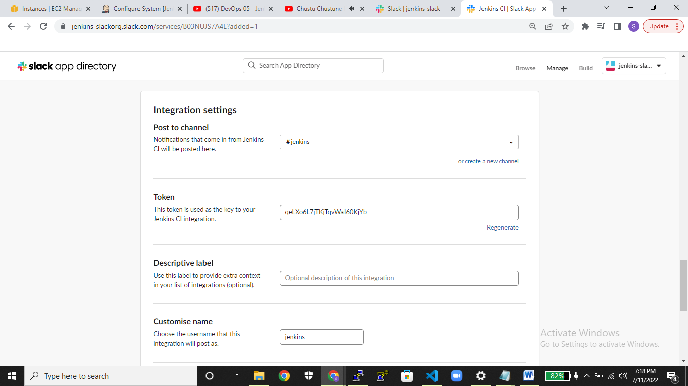  
 **step8:** Goto manage Jenkins click on configure systems scroll down upto slack.  
In workspace give the name were you created workspace name in the slack portal page.   
  
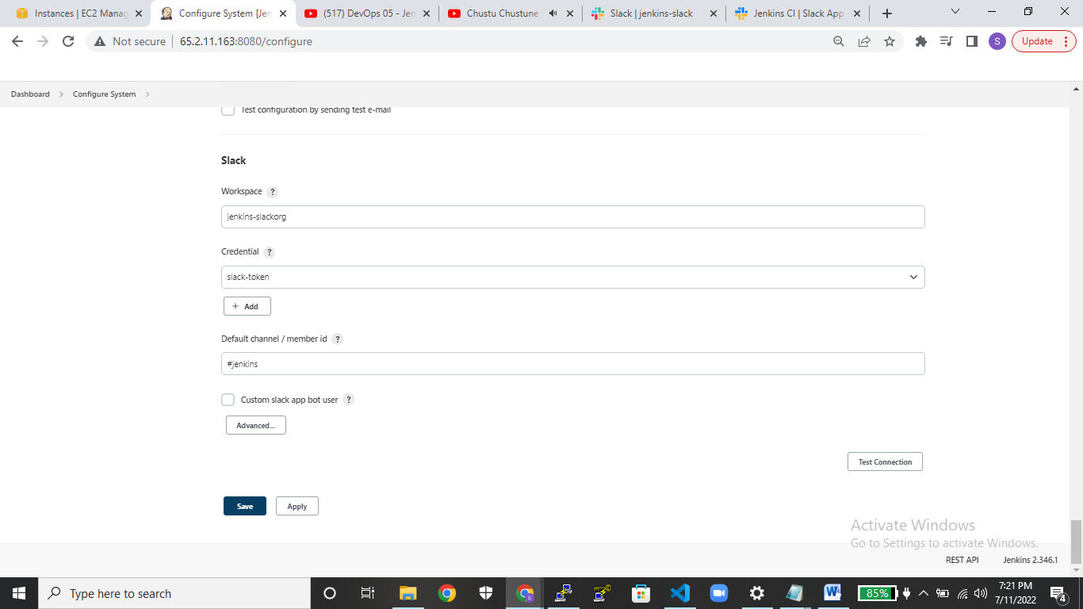

**Step10:** Create the credentials click on the add button then select kind as **secret text.**and under **secret** provide the authentication key were you created the authenticatioin key  
 in slack portal page then click it on add.  
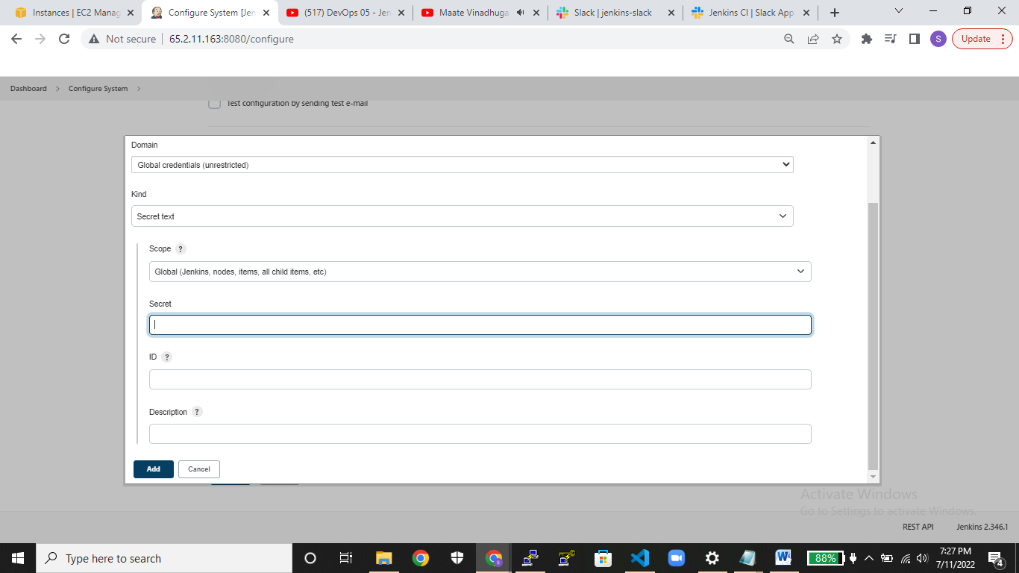  
  
**Step11**: Give channel name were you created channel name in slack portal page.  
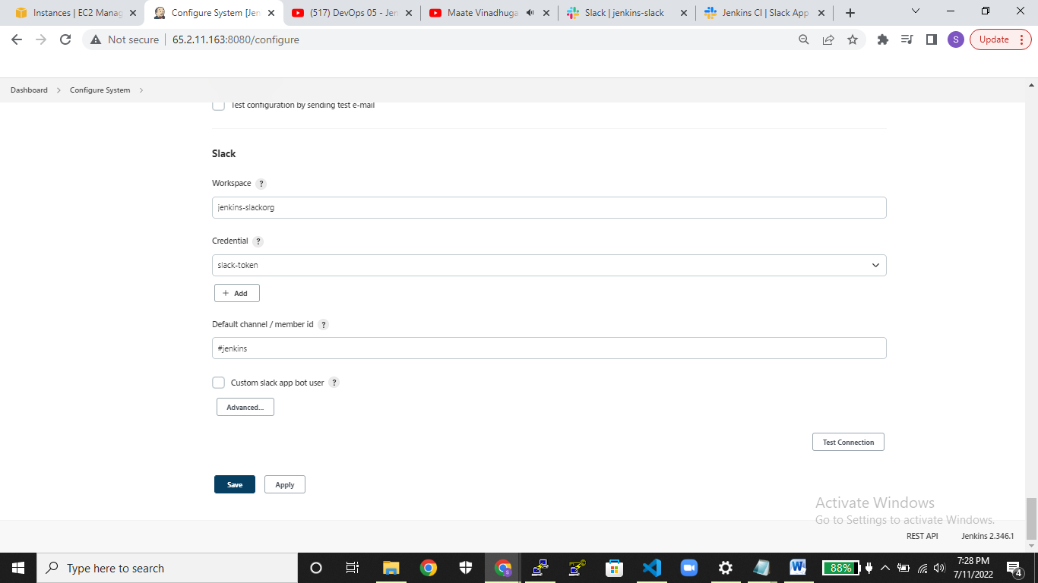

**Step12:** Then click on advanced and click on test connection  
  
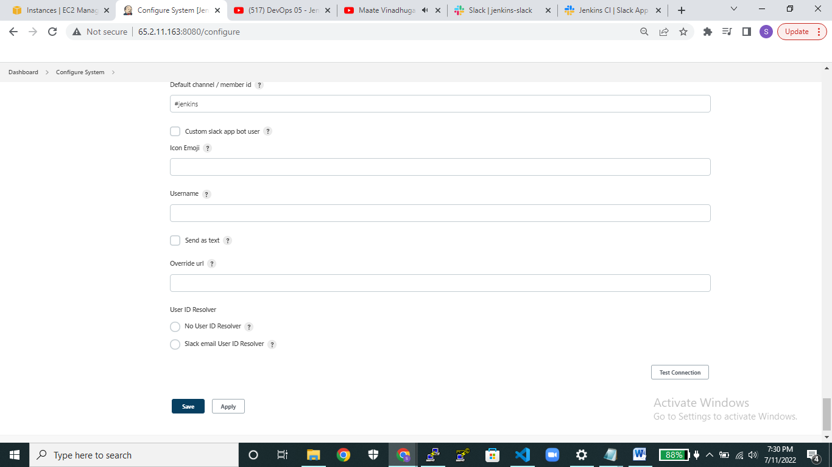  
  
**Step13:** Then go to created pipeline over there click on postbuild-actions under that select slack notifications  
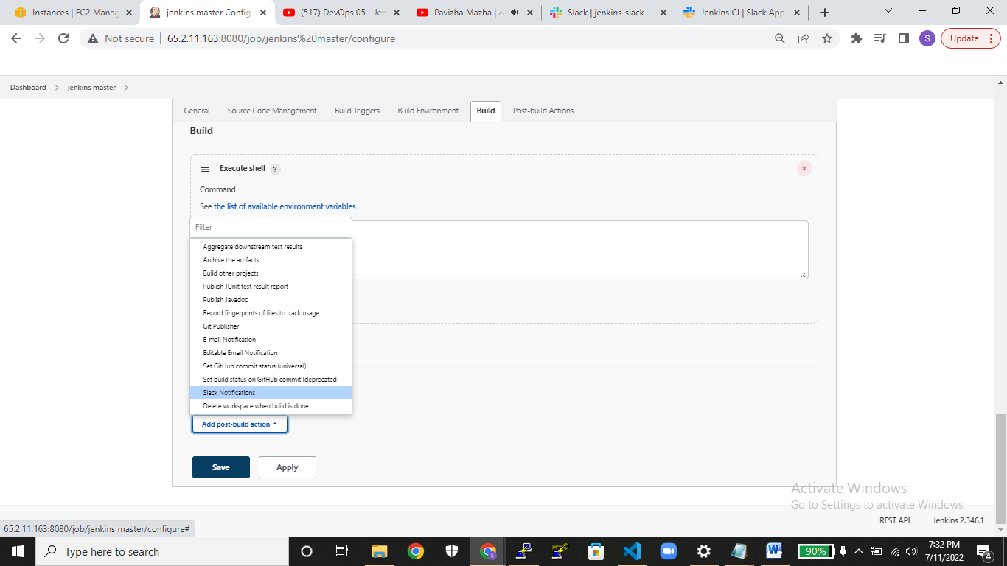  
  
  
 **Step14:** After selecting the slack notification in post-build action click on advance button choose whatever options you need it like for instances ( at that time of failure or else at the time of success )

